Homework 1
Signal and System

Q1) Determine the power of the following signals

(a) 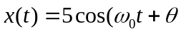
( b)
( c)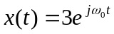

Solution:
- 12.5
Power is the average energy of a periodic signal for a time period T.
Power, 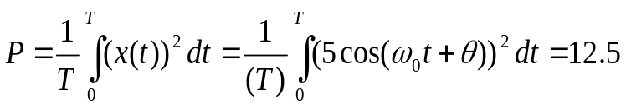

Where, 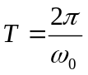
- 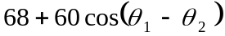

Power,

Where,

- 0

Power,
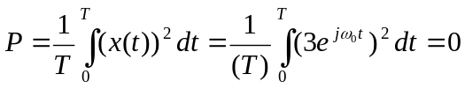
Where,

Q2) Determine the energy of the following signal

(a) 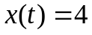
(b) 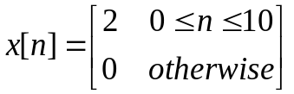
Solution:

- Infinity ,
Energy, 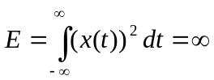 as the signal is not time bounded.
- 44,

Energy, 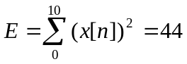

Q3) Find the fundamental period and fundamental frequency of the following signals

(a)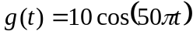
(b)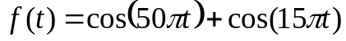
(c)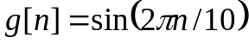
(d)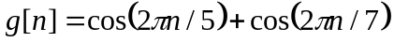
(f) 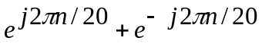

Solution:
- Fundamental period= 0.04
Fundamental frequency=25 (Inverse of fundamental period)

The fundamental period of a signal is the length of a smallest continuous portion of the domain over which the function completes a cycle.

Angular frequency,
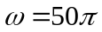

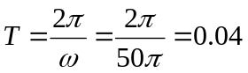

- Fundamental period= 0.4
Fundamental frequency=2.5

Period of first component of signal, T1
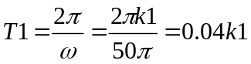

Period of second component of signal, T2

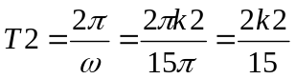

To find the fundamental period we must find the minimum value of k1 and k2 such that the fundamental period T=T1=T2

Hence, 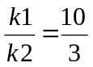, 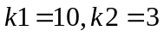

- Fundamental period= 10
Fundamental frequency=0.1

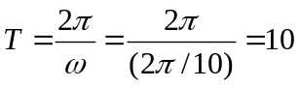
- Fundamental period= 35
Fundamental frequency=0.02857

Period of first component of signal, T1
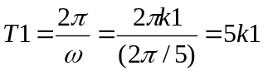

Period of second component of signal, T2

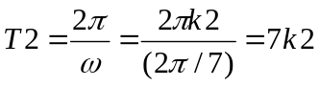

To find the fundamental period we must find the minimum value of k1 and k2 such that the fundamental period T=T1=T2

Hence, 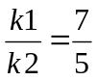, 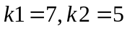
- Fundamental period= 20
Fundamental frequency=0.05

The signal is equivalent to 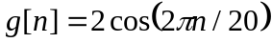

Hence,
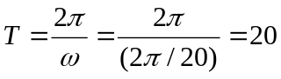

Q4) Determine whether the following systems are (1) memoryless (2) time-invariant (3)
(3) linear (4) Causal or BIBO . Justify your answers.

a)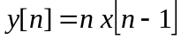
b)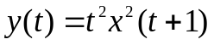
c)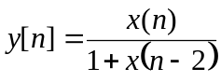
d)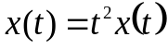

Solution:

  - Memoryless: 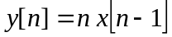 is not memoryless as output depends on the past value of the input
  - time-invariant: is not time-invariant as time shift of k in the input produces a output 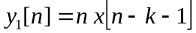 and, time shift of output by k results in the output signal 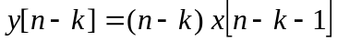. Hence a time shift in the input signal does not lead to an identical time shift in the output signal. Hence it is not time-invariant.
  - Linear: The output signal is linear as the output to the input signal 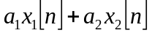 results in 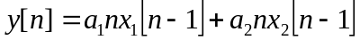 which is equivalent to 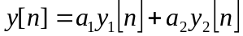. Hence, it satisfies the property of homogeneity and superposition and hence is linear.
  - Causal or BIBO: The output is causal signal as the present value of output signal depends only on the past values of the input signal. The output signal is not BIBO because as n tends to infinity, the output signal tends to infinity and hence is unbounded even if the input signal is a bounded signal.

  - Memoryless: is not memoryless as output depends on the future value of the input
  - time-invariant: is not time-invariant as time shift of k in the input produces a output 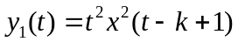 and, time shift of output by k results in the output signal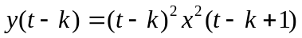. Hence a time shift in the input signal does not lead to an identical time shift in the output signal. Hence it is not time-invariant.
  - Linear: The output signal is not linear as the output to the input signal 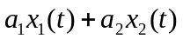 results in 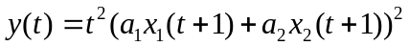 which is not equivalent to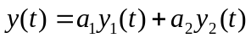. Hence, it does not satisfy the property of homogeneity and superposition and hence is linear.
  - Causal or BIBO: The output is not a causal signal as the present value of output signal depends only on the future values of the input signal. The output signal is not BIBO because as t tends to infinity, the output signal tends to infinity and hence is unbounded even if the input signal is a bounded signal.

  - Memoryless: 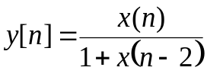is not memoryless as output depends on the past value of the input
  - time-invariant: is time-invariant as time shift of k in the input produces a output 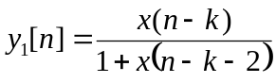 and, time shift of output by k results in the output signal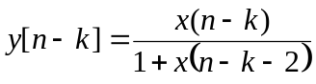. Hence a time shift in the input signal lead to an identical time shift in the output signal. Hence it is time-invariant.
  - Linear: The output signal is not linear as the output to the input signal 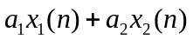 results in 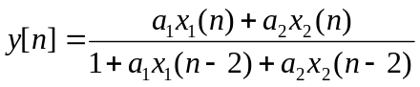 which is not equivalent to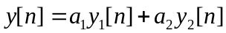. Hence, it does not satisfy the property of homogeneity and superposition and hence is not linear.
  - Causal or BIBO: The output is causal signal as the present value of output signal depends only on the past and present values of the input signal. The output signal is BIBO because as n tends to infinity, the output signal is bounded as long as the input signal is a bounded signal.

  - Memoryless: 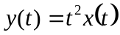is memoryless as output depends only on the present value of the input
  - time-invariant: is not time-invariant as time shift of k in the input produces a output 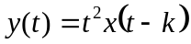 and, time shift of output by k results in the output signal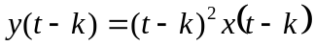. Hence a time shift in the input signal does not lead to an identical time shift in the output signal. Hence it is not time-invariant.
  - Linear: The output signal is linear as the output to the input signal results in 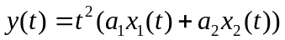 which is equivalent to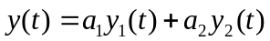. Hence, it satisfies the property of homogeneity and superposition and hence is linear.
  - Causal or BIBO: The output is causal signal as the present value of output signal depends only on the present values of the input signal. The output signal is not BIBO because as n tends to infinity, the output signal tends to infinity and hence is unbounded even if the input signal is a bounded signal.

Q5) Determine whether the following system are Linear time invariant (LTI)

a)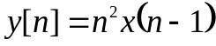
b)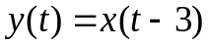
c)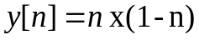
Note: The system consider (LTI) if satisfied two conditions linearity and time-invariant)

Solution:
- 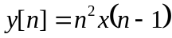 is not LTI system as it is not time invariant.
  - time-invariant: 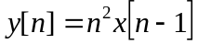 is not time-invariant as time shift of k in the input produces a output 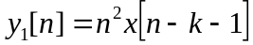 and, time shift of output by k results in the output signal 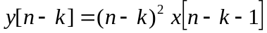. Hence a time shift in the input signal does not lead to an identical time shift in the output signal. Hence it is not time-invariant.
  - Linear: The output signal is linear as the output to the input signal results in 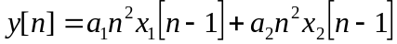 which is equivalent to . Hence, it satisfies the property of homogeneity and superposition and hence is linear.

- 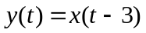 is LTI system
  - time-invariant: is time-invariant as time shift of k in the input produces a output 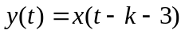 and, time shift of output by k results in the output signal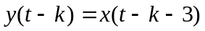. Hence a time shift in the input signal leads to an identical time shift in the output signal. Hence it is time-invariant.
  - Linear: The output signal is linear as the output to the input signal 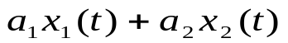 results in 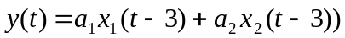 which is equivalent to. Hence, it satisfies the property of homogeneity and superposition and hence is linear.

- 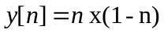 is not LTI system as it is not time invariant.
  - time-invariant: 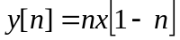 is not time-invariant as time shift of k in the input produces a output 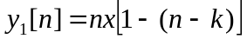 and, time shift of output by k results in the output signal 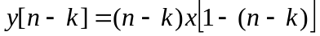. Hence a time shift in the input signal does not lead to an identical time shift in the output signal. Hence it is not time-invariant.
  - Linear: The output signal is linear as the output to the input signal results in 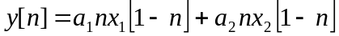 which is equivalent to . Hence, it satisfies the property of homogeneity and superposition and hence is linear.

